Hello Authors! The instructions and template provided here serves a guide for the format and style for manuscripts submitted to The Compass. Additional questions regarding manuscripts can be directed to the editor at editor@sgeearth.org. Please try to use the styles as defined in the document.
Please put the primary author’s name in the footer (where it says “Author et al.”).
Author note: Please delete all red explanatory text (Style: SGE Explanatory Text) when submitting!
SGE Compass manuscript template: Capitalize only proper nouns and avoid using all caps (Style: SGE Title)
James Hutton^{1*}, Alfred L. Wegener^{2,A}, Charles Lyell^{3,B}, and John W. Powell^{2,C} (Style SGE Authors)
Note: Please add superscript numbers for different affiliations. Please add a superscript star (*) for the corresponding author email. You may also add email addresses and ORC-IDs (if present) for other authors by using superscript letters (A-Z).
¹ Affiliation 1, Department, Institution, Full Mailing Address, USA (Style SGE Affiliation)
² Affiliation 2, Department, Institution, Full Mailing Address, USA (Style SGE Affiliation)
³ Affiliation 3, Department, Institution, Full Mailing Address, USA (Style SGE Affiliation)
* Corresponding Author Email: editor@sgeearth.org (Style SGE Affiliation)
^{A} Email: alj@email.com, ORC-ID 0000-0000-0000-0000 (Style SGE Affiliation)
^{B} Email: cl@email.com (Style SGE Affiliation)
^{C} Email: jwp@email.com (Style SGE Affiliation)
ABSTRACT
Abstracts should not exceed 250 words.
(Style: SGE Normal) Lorem ipsum dolor sit amet, consectetur adipiscing elit, sed do eiusmod tempor incididunt ut labore et dolore magna aliqua. Vel eros donec ac odio tempor orci dapibus ultrices in. Scelerisque eleifend donec pretium vulputate sapien nec sagittis aliquam. Tellus orci ac auctor augue mauris augue neque gravida in. Nec ultrices dui sapien eget mi proin. Tristique senectus et netus et malesuada fames. At volutpat diam ut venenatis. Quis lectus nulla at volutpat diam ut venenatis tellus.
KEYWORDS
Please enter four to eight keywords that are relevant to your research, separated by commas.
(Style: SGE Normal) Keyword 1, Keyword 2, Keyword 3, Keyword 4, Keyword 5
INTRODUCTION (Style: SGE Heading 1)
Text for the article goes here. Please include relevant sections such as Introduction, Study Area, Methods, Results, Discussion, Conclusion, and any other necessary sections. Minor headings (First level through 5th level headings, Style SGE Heading 2 - 5) could include Purpose, Geologic Setting, Previous Investigations, and Field Evidence, or appropriate minor headings.
Equations can be entered by the equation tool (Insert > Equation). Please reference the equations in order of appearance and fully explain all variables. You can also make the editor extremely happy by including the LaTeX version of the equation, which is what will need to be done in the final versions of the paper. You can use style SGE Equation LaTeX for it and include the LaTeX code below the Microsoft Word Equation. You can find a good Equation Editor here: https://editor.codecogs.com/.
For example… Equation 1 provides solutions to the quadratic equation, as:
$$x=\frac{-b±\sqrt{b^{2}-4ac}}{2a}$$
x = \frac{-b \pm \sqrt{b^2 - 4ac})}{2a}
Where a, b, and c are … and x is ….
Units should be metric (m, km, km², kg, etc.) but you may put imperial units in parenthesis, like this: “the area of glaciers changed by -53.812 km² (-20.777 mi²), a reduction of 41.62% in area between 1896 and 2021.” The genus/species of organisms need to be placed in italics, e.g., Nautilus pompilius. Try not to use footnotes, but if needed, we can incorporate them into the final document.
Lorem ipsum dolor sit amet, consectetur adipiscing elit, sed do eiusmod tempor incididunt ut labore et dolore magna aliqua. In mollis nunc sed id semper risus in. Sagittis aliquam malesuada bibendum arcu vitae. Sit amet mauris commodo quis. Porta non pulvinar neque laoreet suspendisse interdum. Dictum sit amet justo donec enim diam vulputate ut pharetra. Semper eget duis at tellus at urna condimentum. Dui ut ornare lectus sit amet. Lectus vestibulum mattis ullamcorper velit sed. Sed ullamcorper morbi tincidunt ornare massa eget.
First Level Heading (Style: SGE Heading 1)
Lorem ipsum dolor sit amet, consectetur adipiscing elit, sed do eiusmod tempor incididunt ut labore et dolore magna aliqua. Nisl purus in mollis nunc sed.
Sed tempus urna et pharetra pharetra massa massa ultricies mi. Donec pretium vulputate sapien nec sagittis aliquam malesuada.
Second Level Heading (Style: SGE Heading 2)
Use Style SGE Heading 2 for subdivisions within SGE Heading 1.
Lorem ipsum dolor sit amet, consectetur adipiscing elit, sed do eiusmod tempor incididunt ut labore et dolore magna aliqua. Nisl purus in mollis nunc sed.
Third Level Heading (Style: SGE Heading 3)
Use Style SGE Heading 3 for subdivisions within SGE Heading 2.
Sed tempus urna et pharetra pharetra massa massa ultricies mi. Donec pretium vulputate sapien nec sagittis aliquam malesuada. Lorem dolor sed viverra ipsum nunc aliquet bibendum enim facilisis.
Fourth Level Heading (Style: SGE Heading 4)
Use Style SGE Heading 4 for subdivisions within SGE Heading 3.
Sed tempus urna et pharetra pharetra massa massa ultricies mi. Donec pretium vulputate sapien nec sagittis aliquam malesuada. Lorem dolor sed viverra ipsum nunc aliquet bibendum enim facilisis.
Fifth Level Heading (Style: SGE Heading 5)
Use Style SGE Heading 5 for subdivisions within SGE Heading 4. If you need additional headings, please contact the editor.
Sed tempus urna et pharetra pharetra massa massa ultricies mi. Donec pretium vulputate sapien nec sagittis aliquam malesuada. Lorem dolor sed viverra ipsum nunc aliquet bibendum enim facilisis.
NOTE ABOUT CITATIONS
Citations should be fully referenced in the References Cited section. In-text citation should be written as follows: “…as Rodgers (1957) demonstrated…” or “…it is well documented (Dunbar and Rodgers, 1957; Tevesz et al., 1980)….” You may also use “and others” in lieu of “et al.” for in-text citations, e.g.: “… Tevesz and others (1980) stated ….”
NOTE ABOUT FIGURES AND TABLES
Reference each figure as they appear in the document as an inline citation like: “…Figure 1 clearly shows…” or “… the study area (Figure 1)….” The individual figures will be listed in the “Figures” section below.
Tables are referenced in a similar manner as figures but are included in the “Tables” section below.
ACKNOWLEDGEMENTS
Optional, but can include individuals who assisted in the study, reviewers, funding agencies, etc.
(Style: SGE Normal) Lorem ipsum dolor sit amet, consectetur adipiscing elit, sed do eiusmod tempor incididunt ut labore et dolore magna aliqua. In mollis nunc sed id semper risus in. Sagittis aliquam malesuada bibendum arcu vitae. Sagittis aliquam malesuada bibendum arcu vitae. Sagittis aliquam malesuada bibendum arcu vitae.
REFERENCES CITED
Use Style SGE References. Citations are to appear in alphabetical order. Please refer to the GSA reference guidelines and examples at the following URL for formatting your references cited section: https://www.geosociety.org/documents/gsa/pubs/GSA_RefGuide_Examples.pdf . Also, please use Digital Object Identifiers (DOI) when you can… you can search for DOI’s at the following site: https://search.crossref.org – Doing this step will make the editor really happy!
Bagnold, R.A., 1960, Some aspects of the shape of river meanders: United States Geological Survey Professional Paper 282-E, 144 p., doi: 10.3133/pp282e.
Dunbar, C.O. and Rodgers, J., 1957, Principles of Stratigraphy: John Wiley & Co., New York, New York, 356 p.
Illinois Geospatial Data Clearinghouse, 2015, 1937-1947 Illinois historical aerial photography: https://clearinghouse.isgs.illinois.edu/data/ imagery/1937-1947-illinois-historical-aerial-photography (Accessed September 2015).
Landes, K.K., 1966, A scrutiny of the abstract, II: Bulletin of the American Association of Petroleum Geologists, Vol. 50, No. 9, p. 1992, doi: 10.1306/v50-09-p1992.
Rhoads, B.L., Best, J., Johnson, K., and Engel., R.F., 2009, Flow structure and channel change in a chute cutoff along a large meandering river: Abstract H44C-02 presented at 2009 American Geophysical Union Fall Meeting, San Francisco, California, 14-18 December, 2009.
Rodgers, J., 1959, The meaning of correlation: American Journal of Science, Vol. 257, No. 10, Pp. 684-691, doi: 10.2475/ajs.257.10.684.
Tevesz, M.J., Soster, F.M., and McCall, P.L., 1980, The effects of size-selective feeding by oligochaetes on the physical properties of river sediments: Journal of Sedimentary Petrology, Vol. 50, No. 2, Pp. 561-568, doi: 10.1306/212f7a4f-2b24-11d7-8648000102c1865d.
Figures
Figures should be high resolution (at least 300 dpi; 600 dpi preferred) and scaled to fit a maximum of 7.5 inches wide by about 7.5 inches tall (to allow room for a figure caption). Please do not wrap text around the image. Final rendered images for publication may be 3.667 to 7.5 inches wide, depending on the column span in the final publication (ensure readability!). We prefer vector-based images (svg, png, etc) versus raster image formats (jpg, gif, etc); raster image formats are okay as long as they have high-enough resolution. Graphs should be rendered in high resolution; preferred in R or other statistical program, but we can also use graphs made in Microsoft Excel. Maps should contain all necessary map elements (north arrow, scale bar, legend, reference to a larger geographic location [i.e., a map that shows a study area shows a larger area, like a state or country], etc.); consider having geographic coordinates on the collar of the image to help the reader orient to the location (see Figure 2 for example of this). You can also attach figures separately if they are too large or make the document too large (over about 10 mb). Please generate alternative text for the figure for accessibility and those readers who will utilize screen readers – see the green text below the figure caption.
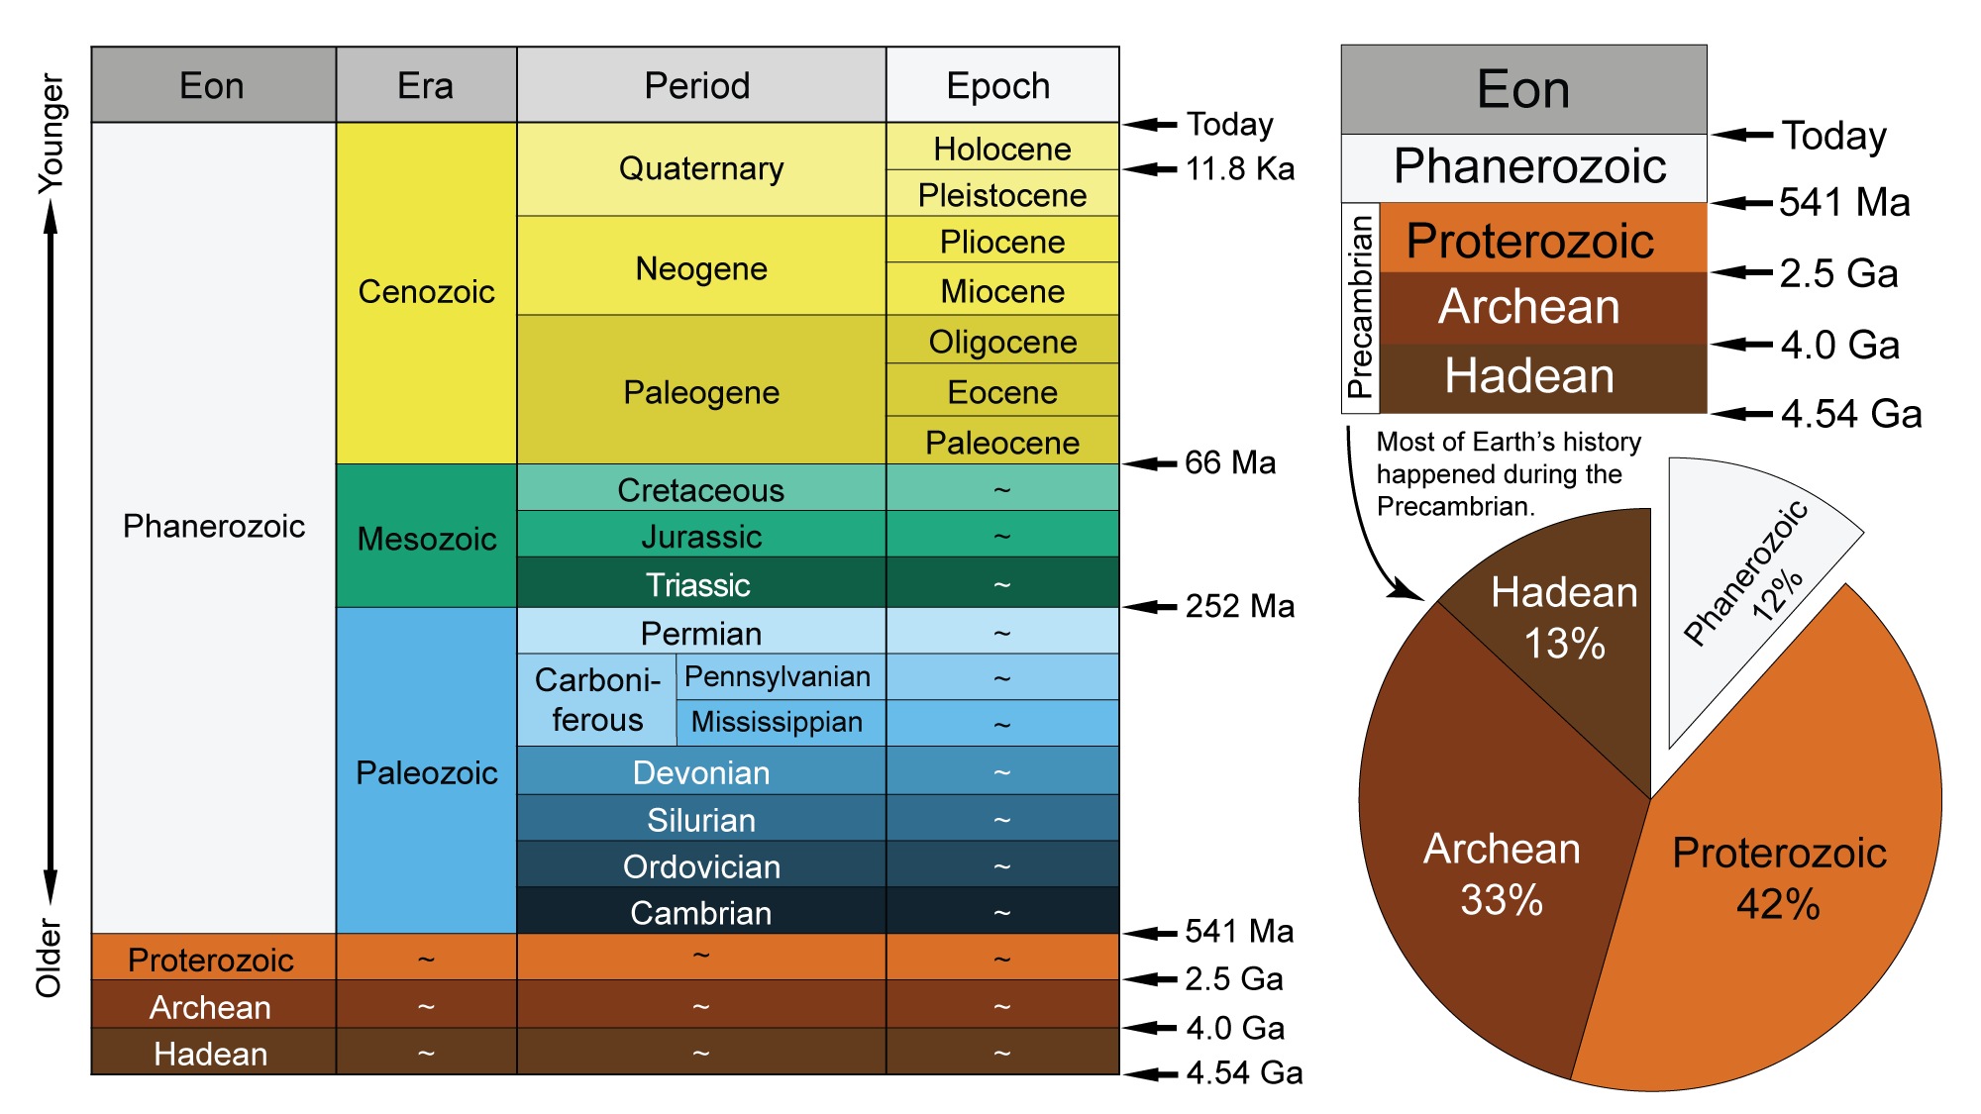
Figure 1: Figure Caption goes here. Style SGE Figure Caption.
Figure Alternative Text (Style SGE Alt Text). Click here to learn about how to generate good alternative text for images. Alternative text should describe the figure and should NOT be a repeat of the figure caption. Example alternative text for the above figure would be something like: Geologic timescale showing the geologic eons, eras, periods, epochs, and associated dates in billions of years (Ga), millions of years (Ma), and thousands of years (Ka). On the left is a colored table that shows each eon, era, period, epoch, and associated age. On the upper right is a colored table that shows only the eons and associated ages. On the lower right is a pie chart that shows the relative percentage of time that each eon represents.
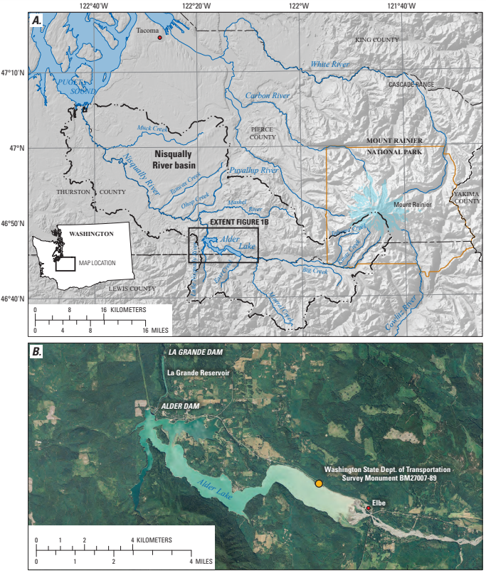
Figure 2: Example of a map element figure showing all necessary map elements, including geographic information in the collar. You may reference Figure 2A and Figure 2B both in the figure caption and text.
Figure alternative text goes here.
Tables
Tables may be included either in the text or as attached Microsoft Excel tables. If you choose to include the table here, please keep all borders and use the necessary styles (SGE Table Header, SGE Table Cell). Tables that wrap over multiple pages will be dealt with prior to publication. Tables that may not be completely relevant to the section or paper can be included as an appendix (see instructions for that below). You may also include table comments (Style SGE Table Comment) that will appear below the table, with necessary reference notations as superscripts.
Table 1: Table caption goes here. Style SGE Table Caption.
Header | Header | Header¹ | Header²
Data | Data | Data | Data
Data | Data | Data | Data
Data | Data | Data | Data
¹ Table comment 1 Goes here. In mollis nunc sed id semper risus in. Sagittis aliquam malesuada bibendum arcu vitae. Sagittis aliquam malesuada bibendum arcu vitae.
² Table comment 2
Table 2: Table caption goes here.
This is an example of a table that would be included externally (as a Microsoft Excel document). Please include the table caption but make a note in the document with the file name.
Table is included externally as “table2.xlsx”.
Appendices
Appendices should be referenced in order as they are mentioned in text, and only should be used if necessary. Text, figures, and tables all can be referenced in a similar manner as text, figures, and tables for the rest of the document. You may reference tables and figures in the appendices as “Appendix A-1”, etc.
suggested peer reviewers
In this section, please list the name and contact information for a couple of potential peer reviewers. The editor may choose to use different peer reviewers.
Next Steps:
- Ensure all figures have alternative text (green text below figures noted above).
- Download, sign, and submit a Permissions Form granting us permission to publish your work – we need this at the same time as the manuscript is submitted. You can find the permissions form at https://sgeearth.org/the-compass/.
- Submit the manuscript, permissions forms, and any ancillary materials to the editor as email attachments to editor@sgeearth.org.
- The editor of The Compass will solicit each manuscript for peer review. Once comments are received from the peer reviewers, the editor will send comments back to the corresponding author for review, edit, and incorporation. It is understood that it is the author’s responsibility to revise the manuscript to acceptable standards. Submitted manuscripts that do not follow this step will be returned and risk nonpublication.
Questions and Answers: If you have any additional questions or style elements not mentioned in this document, please forward your questions/comments to the editor at editor@sgeearth.org.

